

***DEPARTMENT OF COMPUTER SCIENCE ENGINEERING,***

***SCHOOL OF ENGINEERING AND TECHNOLOGY,***

***SHARDA UNIVERSITY, GREATER NOIDA***

**BRAIN TUMOR SEGMENTATION**

***A project submitted***

***in partial fulfillment of the requirements for the degree of***

***Bachelor of Technology in Computer Science and Engineering***

by:

**Yatender (2018009735)**

**Jitesh (180102028)**

**Rahul Kumar (2018005024)**

**Supervised by:**

**Ms. Deepti Sahu, Asst. Prof. (CSE)**

**Sharda University**

**May, 2022**

## DECLARATION

We hereby declare that the project entitled “BRAIN TUMOR SEGMENTATION” submitted for the course of Major Project II (CSP496) is our original work. We have adequately cited and referenced the original sources. We also declare that we have adhered to all principles of academic honesty and integrity and have not misrepresented or fabricated or falsified any idea/data/fact/source in my submission. We understand that any violation of the above will be cause for disciplinary action by the Institute and can also evoke penal action from the sources which have thus not been properly cited or from whom proper permission has not been taken when needed.

#### Signature of the Student(s)

Place: Sharda University

Date:

## CERTIFICATE

This is to certify that the report entitled “**BRAIN TUMOR SEGMENTATION**” submitted by “YATENDER (2018009735), RAHUL KUMAR (2018009735) & JITESH SINGH (2018014918)” to Sharda University, towards the fulfillment of requirements of the degree of Bachelor of Technology is record of bonafide final year Project work carried out by them in the Department of Computer Science and Engineering, School of Engineering and Technology, Sharda University. The results/findings contained in this Project have not been submitted in part or full to any other University/Institute for award of any other Degree/Diploma.

Signature of Supervisor

Ms. Deepti Sahu

Asst. Prof. (CSE)

Sharda University

Signature of Head of Department

Dr. Nitin Rakesh

Place: Sharda University

Date:

**Signature of External Examiner**

**Date:**

## ACKNOWLEDGEMENT

A major project is a golden opportunity for learning and self-development. We consider our self very lucky and honored to have so many wonderful people lead us through in completion of this project.

First and foremost, we would like to thank Dr. Nitin Rakesh, HOD, CSE who gave us an opportunity to undertake this project.

My grateful thanks to **Ms. Deepti Sahu, Asst. Prof. (CSE), Sharda University** for her guidance in our project work. **Ms. Deepti Sahu, Asst. Prof. (CSE), Sharda University** who in spite of being extraordinarily busy with academics, took time out to hear, guide and keep us on the correct path. We do not know where we would have been without her help.

CSE department monitored our progress and arranged all facilities to make life easier. We choose this moment to acknowledge their contribution gratefully.

Name and signature of Students

YATENDER (2018009735)

RAHUL KUMAR (2018009735)

JITESH SINGH (2018014918)

**Contents**

DECLARATION 2

CERTIFICATE 3

ACKNOWLEDGEMENT 4

ABSTRACT 7

1. Chapter-1: INTRODUCTION 8

1.1. Overview: 10

1.2. Project overview 10

1.2.1. Introduction 10

1.2.1.1. Input 13

1.2.1.2. Processing 13

1.2.2. Normal Requirements 14

1.2.3. Non-Functional Requirements 14

1.2.3.1. Performance Requirements 14

1.2.3.2. Reliability 14

1.2.3.3. Availability 14

1.2.3.4. Security 14

1.2.3.5. Maintainability 15

1.2.3.6. Ability of Learning 15

1.3. Project Description 15

1.4. Requirement Specifications 16

1.4.1. Hardware Specifications 16

1.4.2. Software Specifications 17

2. Chapter-2: LITRETURE SURVEY 18

2.1. Existing System 18

3. Chapter-3: METHODOLOGY 20

3.1. Proposed Mechanism 20

3.2. Proposed Structure 20

3.3. Proposed Model [Detailed] 21

3.4. Breakdown Of the Proposed Model 22

4. Chapter-4: DEVELOPMENT BASIS 27

4.1. Feasibility Study 27

a) Technical Feasibility 28

b) Cost Feasibility 28

c) Social Feasibility: 29

4.2. Risk Management 30

4.2.1. Risk Identification 30

4.2.2. Strategies used to manage Risks 30

4.3. Testing 31

4.3.1. Software Testing 31

4.3.1.1. Introduction: - 31

4.3.2. Testing Strategies: 31

4.3.2.1. Unit Testing: - 31

4.3.2.2. Integration Testing: - 31

4.3.2.3. Validation Testing: - 31

4.3.2.4. GUI Testing: - 32

4.4. Test Cases: 33

5. Chapter-5: IMPLEMENTATION AND OUTPUTS 35

5.1. Implementation 35

5.1.1. Preprocessing: 35

5.1.2. Feature Extraction 36

5.1.3. Segmentation 37

5.1.3.1. Segmentation using K-means: 37

5.1.3.2. Segmentation using FCM: 38

5.1.4. Classification 39

5.2. Outputs 40

6. Chapter-6: ADVANTAGES 47

7. Chapter-7: CONCLUSION 48

8. Chapter-8: FUTURE SCOPE 49

9. Chapter-9: REFERENCES 50

## ABSTRACT

Brain image segmentation is a crucial step in many clinical applications and is solely the most vital problems in medical images processing. Image segmentation is often utilized within brain MRI analysis for measuring and visualizing anatomical features, assessing brain changes, identifying tainted areas, surgical planning, and image-guided therapies. Various segmentation approaches with varying degrees of accuracy and complexity have been proposed and described in the compositions of last couple decennia. In this paper, an alternative hybrid strategy that combines conventional K-means segmentation (soft clustering) algorithm with Fuzzy-C-Means (hard clustering) algorithm, enabling tumor identification of MRI scans with minimum human interaction is proposed. During the work sightseeing the most prevalent approaches for brain MRI segmentation and exploring their skills, benefits, and limits, as well as the distinctions between them were key observations.

Keywords: Magnetic Resonance Image/Imaging (MRI), Clustering

## Chapter-1: INTRODUCTION

Over the prior several decades, the lightning advancement in non-invasive brain imagery technologies has opened up advanced vistas in the study and investigation of brain architecture and function. Magnetic resonance imaging (MRI) has made significant progress in gaining access to brain damage and studying brain structure (MRI) [1]. Improvement in brain MR imaging have also resulted in a pile of extensive number of high-quality data. Manually collecting vital information from these huge and intricate MRI datasets has become a monotonous and difficult job for clinicians. This manual assessment might be time-consuming and error-prone due to multiple interstates or intraoperation variability studies [2]. Because of the difficulties in analyzing brain MRI data, computational techniques to improve sickness diagnosis and testing were developed. In serving doctors, making qualitative diagnosis, computerized MR image segmentation, registration, and visualization methods are increasingly adapted.

As Segmentation affects the outcome of the overall investigation, brain MR Image segmentation is an important job in many clinical implementations [3]. This is in view of several processing stages which rely on correct anatomical region segmentation. For example, MR Image segmentation is often practiced to measure and visualize various brain regions, to delineate lesions, to analyze brain enlargement, and to design image-guided treatments as well as surgery. This kind of acceptance led to the development of a wide range of image processing applications, numerous segmentation approaches with varying degrees of precision and complexity have been developed [11].

We looked at some of the most prominent approaches for brain MRI segmentation. We discussed their potentials, benefits, and limits, as well as the distinctions between them. We initially educate the reviewer to the basic notions of image segmentation in order to familiarize the scholar to the intricacy of the brain MRI segmentation complication and its obstacles. These covers describe 2-D and 3-D pictures, outlining problems in an image such as segmentation. Image characteristics presents MR Imaging brain tissue intensity distributions. Then we go through several MRI preprocessing techniques such as nonbrain tissue removal, bias field correction, and image registration. Finally, we reviewed the plausibility challenge in brain MRI segmentation after analyzing diverse brain MRI segmentation approaches.

To assist clinicians in making qualitative diagnosis, computerized MR image segmentation, registration, and visualization methods are increasingly routinely used. Brain MRI segmentation is a significant job in many clinical applications since it impacts overall scrutiny end result. As its multiple processing steps depend on accurate segmentation of anatomical regions. MRI segmentation, for example, is commonly used to measure and visualize diverse brain regions, identify lesions, assess brain development, and plan image-guided interference with surgery. Numerous segmentation algorithms with differing degrees of precision and complexity have been developed due to the large range of image processing applications.

The most prevalent methodologies for brain MRI segmentation are examined in this paper. We go over their abilities, benefits, and obstructions, moreover the differences between them. We begin by teaching the reader the fundamentals of image segmentation before moving on to the intricacy of the brain MRI segmentation complications and its challenges. Defining images, establishing an image segmentation complications and picture attributes, along with displaying MRI brain tissue strength issuance are all covered in this section. Then we'll go into image registration, bias field correction, and nonbrain tissue removal, among other MRI preparation techniques. Finally, after examining various brain MRI segmentation algorithms, we investigate the effectiveness drawback in brain MRI segmentation.

## Overview:

To describe the learning model used, the specification and implementation of algorithms, we needed to investigate the most recent approaches to the subject of Tumor identification. We define the project and compare the strategies proposed in this chapter as potential candidates.

## Project overview

## Introduction

MR Images are accepted broadly to diagnose brain tumors. Therefore, improvements to tumor detection and prediction-based systems based on MRI data are needed. But in the early stages of diagnostic imaging such as MR Imaging, appropriate identification of tumor cells and the fragmentation of neighboring soft tissues is a challenging chore that could be due to the existence of low light in thought patterns or maybe complexity and abnormalities, active size and unexpected areas of the lesion.

The detection of autoimmune malformations in the diagnosis of the head tumor on MR Imaging is significant because it comes up with information regarding unusual tissue needed for planning and treatment. Research in recent publications has also reported that automated computer-assisted diagnosis and diagnosis based upon medical image assessment, could be an effective substitute as this could save a radiologist's time and regain established precision. In addition, if computed algorithms can provide robust, multidimensional tumor estimation, this automatizes the capacities which will be of great assistance in clinical administration of tumors by setting physicians free from burden of tumor exposure [7].

Medical imaging technologies have revolutionized medical diagnosis in the last 40 years, permitting physicians to disclose cancers in early stage and enhance prognosis. It also allows doctors to use a range of imaging technologies to investigate the inner architecture and functions of the human body, as well as plan treatments and course of action. Common medical imaging techniques includes ultrasonography (US), computed tomography (CT), and magnetic resonance imaging (MRI). MRI is the most commonly used method for diagnosing brain tumors since it provides precise information including the kind, position, and size of the tumor under investigation. It can also discern soft tissues with high resolution and it further delicate to detect and visualize precise changes in tissue volume as well as the physiological changes linked to tumors. Furthermore, MRI can help doctors transition from an indirect diagnosis based on cerebral angiography to a specific lesion identification [9]. Moreover, MRI varies from other medical technologies in that as it can create many images of the same tissue utilizing diverse image capturing techniques, allowing for variable contrast imaging. These procedures may differ slightly, but they all provide more important anatomical knowledge to let clinicians examine sick brains more thoroughly.

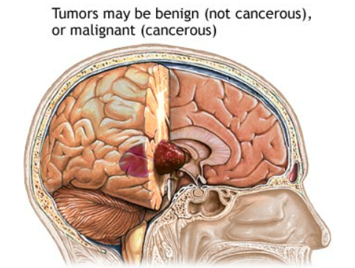

Fig.1: Displays a brain’s anatomical structure

T1-w images, which are basic pulse sequence in magnetic resonance (MR) imaging, intensities, and T2-w images, which are anatomical pictures and useful for the black hole identification, emerge as a hypo-intense or dark area when compared to the white matter (WM) intensities. T2-w images, on the other hand, are useful for the tissue pathology as it clearly reveals tumor outlines. Moreover, the WM lesions appear as hyper-intense or bright areas when compared to the WM intensities. As a result, T2-w images are very effective in detecting pathology. The primary downside of this approach is its severity of CSF, grey matter, and cancers are all relatively comparable. Although using these two MRI procedures can make it difficult to differentiate among new and old tumor, or tumor from non-tumoral lesions, in summation to grading, T2-w and T1-w are the most commonly used procedures for diagnosing brain tumors in clinical practice [1]. The utilization of advanced computational instruments and digital image processing technology is required for the analysis of such MR pictures. It is sometimes required to use a contrast enhancement agent to adequately emphasize the extremity of a brain tumor in T1-w images. As it is crucial for differentiating and recognizing particular types of brain tumors in T2-w and T1-w images.

One of the particular challenges is the diagnosis of brain tumors in MR imaging, as the existence of a brain tumor may be associated with a very nonuniform signal that might be connected to the signal stability of normal tissue. Because of the MR image's low intensity resolution and the intricacy of human brain structure, uncertainty in pixel classification inside the tumor region could lead to incorrect segmentation. When some parts of the tumor can't be isolated from the WM/GM, this happens. This happens along the border of the brain tumor and neighboring normal tissue due to the impact of partial volumes. As a consequence, the partial volume softens the MR images to the point that each centroids intensity values are blended with their neighbors.

## Input

* Tumored Brain MR Image as a Test Image.
* Prior to use the framework must be fully prepared and a customer should have a clear understanding of the specific framework.

## Processing

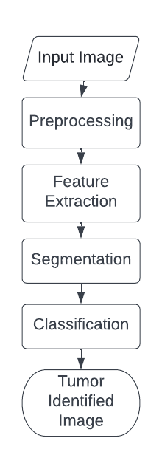

Fig.2. Proposed Method Flowchart

## Normal Requirements

These are the demands specifically specified by the consumer, so criteria for customer satisfaction must be present.

N1: The program should provide a user interface with graphics.

N2: Feedback should identify tumors of different sizes and types.

## Non-Functional Requirements

These are the specifications, as the name implies, that are not specifically correlated with particular functions offered by the device.

## Performance Requirements

Execution based on the relation, high execution of the PC may involve one or more of the accompanying: fast reaction time for a certain bit of work. In comparison to the time and assets used, execution is defined by the measure of useful work done by a PC framework or PC system.

## Reliability

Unwavering quality is a property of any component related to a PC (for example, programming, or equipment, or system) that performs consistently as its determinations indicate. For some time, it has been seen as one of three related characteristics that should be considered when making, buying, or using an object or part of a PC.

## Availability

Accessibility is a general concept used in PC systems and system management to describe the measure of time over a one-year span that the framework assets are available in the wake of partial system disappointments. A structure with all its properties that is continually available is seen as fruitful.

## Security

Security (or PC security) in registration is the technique to ensure that information placed on a PC cannot be accessed or negotiated without approval by any person. Data encryption and passwords are the majority of PC efforts to develop security. Encryption of information is the interpretation of data into a structure that is indiscernible even without a method of disentanglement. A watchword is a coded word or phrase that grants access to a project or structure to a customer.

## Maintainability

It is defined as the probability within a given time of conducting a successful repair operation. As such, practicality tests the straightforwardness and speed at which, after a disappointment occurs, a system can be returned to operating status. Convenience is a trademark that is credited to a PC application in the event that it may be used rather than the one in which it was developed as part of operating systems without the need for major reconstruction. Porting is the job of performing whatever work that is necessary to maintain the PC program going in the new environment.

## Ability of Learning

It is simple to operate and reduces the learning function should provide a user interface with graphics.

## Project Description

Aneurysms, subdural hematomas, ischemia - these are just some of the brain injuries that can cause seizures. A more uncommon but still serious type is called brain tumor. These tumors originate in parts of your brain where thoughts are formed that controls your sense of sight, touch, sound, heat, smoke and that helps you understand speech. There are many types of tumors, but tumors at this level cause seizures, nausea and vomiting, difficulty with visual perception and speech comprehension. Tumor is the result of abnormal growth and cellular proliferation in the brain. If it is not identified earlier and correctly, it may lead to some serious consequences or ultimately death. Diagnosing brain tumor is a typical task as brain is enclosed within skull making it difficult to approach for study and diagnosis purposes. The only optimal solution to this problem is ‘Image Segmentation’. We will use Tumored MR Images and segment them with the help of feature extraction to identify tumor.

## Requirement Specifications

## Hardware Specifications

|  |  |
| --- | --- |
| Mandatory Requirements | Specifications |
| Operating System | Windows |
| Central Processing Unit | Dual core |
| Random Access Memory | 2 Giga Bytes RAM |
| DISK Space | The amount of disc space available  depends on the partition size and whether  or not online help files are allowed. The  Math Works installer would tell you how  much disc volume your partition needs. |
| GPU | GPUs with computing capability 2.0 or higher |

|  |  |  |  |  |
| --- | --- | --- | --- | --- |
| Recommended Requirements | | Specifications | | |
| IDE | Processor | RAM | DISK Space | GPU |
| MATLAB | Intel 10th Generation i3 | 2 Giga Bytes | 10 Giga Bytes for MATLAB only. 1 Giga Byte for a project code installation | GPU with computing capability 3.0 is strongly recommended |

## Software Specifications

|  |  |
| --- | --- |
| IDE | Language |
| MATLAB | m |

## Chapter-2: LITRETURE SURVEY

## Existing System

* **“Enforcing temporal consistency in Deep Learning segmentation of brain MR images”** [4]**:**
  + Using Image Augmentation for Cropping and resizing.
  + This method focuses on including the subject in the frame with random cropping scheme.
  + Augmentation manipulates image in various ways like resizing, flipping and rotating, etc.
  + Time consuming and lack of symmetricity affecting result verification.
* **“Adaptive fuzzy segmentation of magnetic resonance images”** [18]**:**
  + Conventional FCM has limitation of imperfection to the abnormality of brain.
  + FCM is incapable in working with images having noise.
  + In spite of FCM, K-means clustering is noise immune and emphasizes segmentation.
* **“Feature Extraction of Brain Tumor Using MRI”** [14]**:**
  + K-means clustering works well even with noisy images but on condition of suitable thresholding.
  + Human interaction is required to enter number of clusters.
  + K-means finds it difficult to form clusters of different sizes and densities.
* **“Classification of Brain MRI Tumor Images: A Hybrid Approach”** [8]**:**
  + PCA (principal component analysis) for classification and Discrete Wavelet Transform (DWT) for feature extraction are used.
  + SVM is required which performs well with CNN.
  + RMS error rate is high.
* **“A Hybrid Approach based Segmentation Technique for Brain Tumor MRI Images”** [10]**:**
  + Seed Region Growing and Threshold Segmentation approach are used.
  + Seed region growing is unable to expose the holes in the tumor
  + Results depends upon the similarity measures used.

|  |  |
| --- | --- |
| **Technique Used** | **Limitations** |
| Image Augmentation | Lack of symmetricity affecting result verification |
| Fuzzy C Means | Incapable of working with noise |
| PCA and DWT | CNN needs to be implemented; RMS error rate is high |
| Seed Region Growing and Threshold Segmentation | Results can be unexpected and performance could be an issue. |

## 3. Chapter-3: METHODOLOGY

## Proposed Mechanism

1. Filters are used for Preprocessing purpose.
   * They can also help in locating tumors.
2. K-means machine learning method based on Centroid defining theory.
   * Used for Proper selection of heterogenous parts with clusters to emphasize segmentation initially.
   * It handles nonlinear data and can classify it on the least amount of data available for training.
3. Fuzzy C-means could be used to verify brain tumors for accuracy.
   * Fuzzy C-means distributes updated membership obtained by calculating distance from cluster center to the data point.

## Proposed Structure

This will be our project structure that we are following throughout the development:

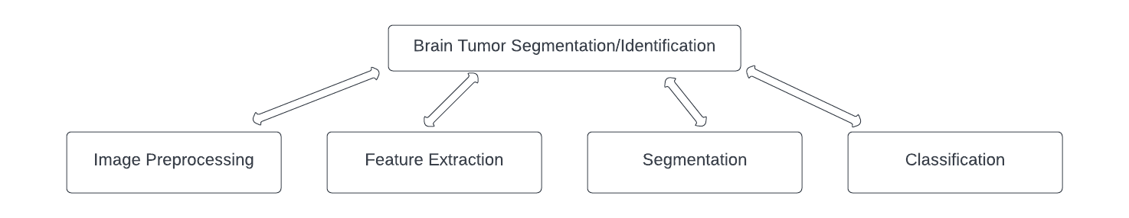

Fig. 3: Structural Overview of Proposed Mechanism

## Proposed Model [Detailed]

The suggested Identification scheme is listed in this section. Below figure consists of a standard Tumor Identification system.

Figure shows a general schematic of the method.

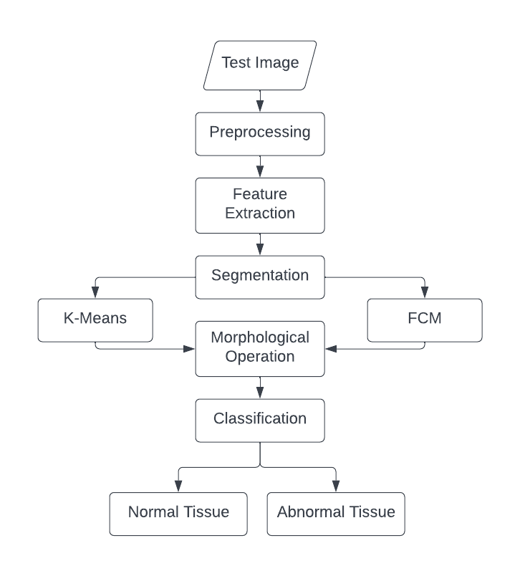

Fig 4: Steps used in the proposed model

## Breakdown Of the Proposed Model

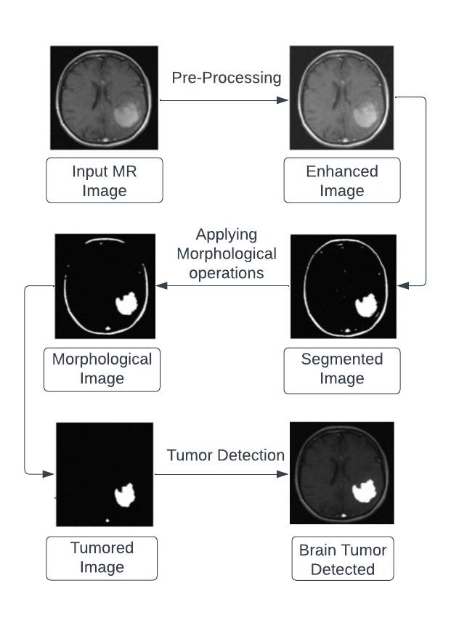

Fig. 5: This Figure shows the sequence of functions being applied onto the image

**Preprocessing**

The goal of this stage is to increase the MRI's quality and change it into something usable for future processing. Furthermore, preprocessing aids in the improvement of some MR picture metrics, such as the signal-to-noise ratio, the visible aspect of the MR image, and the removal of irrelevant noise and unwanted fragments in the surrounding while keeping the edges.

* Enhance the quality of MR images and prepare them for subsequent processing by a human or machine vision system.
* Preprocessing aids in the improvement of specific MR image metrics such as the Signal-to-Noise ratio, Visual appearance enhancement, noise removal, unwanted parts in the background, and edge preservation.

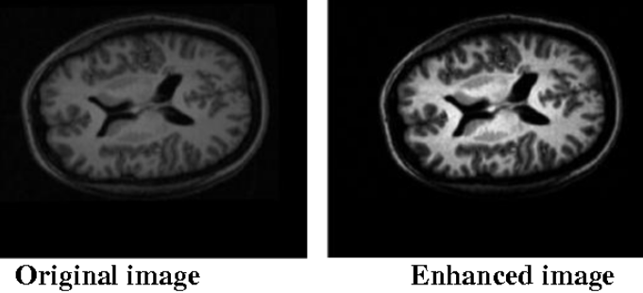

Fig.6: Test image after pre-processing/Enhancement

**Segmentation**

* The pre-processed MR picture of the brain is converted to a binary image with a cut-off threshold.
* Pixel values larger than the threshold are mapped to white, while others are designated as black; as a result, two distinct zones form surrounding infected tumor tissues, which are clipped out.
* A morphological erosion technique is used to get rid of the white pixels.
* Finally, the original picture and the eroded region are separated into two parts, with the black pixel region derived from the erode process being sum up as a brain MR image mask.

**Pseudo-Code:**

**Input**: Enhanced and Gray scaled MR Image

**Output**: Lesion segmented out of normal tissues.

**Phase 1**: Starting off

**Phase 2**: Pick the Picture.

**Phase 3**: Repeat x = 0 for Image Height.

**Phase 4**: Repeat to y = 0 for Image width.

**Phase 5**: Scan the Vertical Pixel Column for each pixel.

**Phase 6**: Extract the pixel value for each pixel from binary matrix.

**Phase 7**: If value more than threshold is found for a pixel with no black pixel, then mark it in cluster template.

**Phase 8**: Make a stop

**Morphological operation**

For the extraction of border areas of brain pictures, the morphological procedure is used. Because this procedure only reorders the relative order of pixel values and not their numerical values, it is only applicable for binary images. Morphology's primary operations are dilation and erosion. Dilation involves connecting pixels to the object's boundary region, whereas erosion involves removing pixels from the object's boundary region.

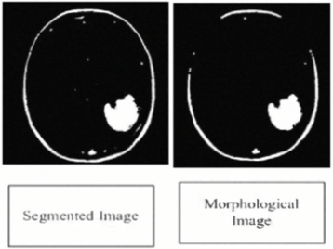

Fig. 7: Image after being morphologically operated

**Feature Extraction and Classification**

* The measurements' observative properties are the features of the input data used to analyze or distinguish these instances of data. Feature extraction aims to choose the appropriate components. Specific characteristics that are mutually distinct and discriminate well throughout instances.
* According to the report, this could be the most crucial factor to choose a feature extraction tool. A critical component in achieving a high level of acceptance. Tumor images are extracted using a variety of techniques, each with its own set of characteristics, invariance properties.
* The question of which approach is ideally suited to a particular case must be tested experimentally.
* Intensity, Contrast, Homogeneity and texture features of MRI images are extracted and used for classification.
* Preprocessed image features are retrieved to this extent that maximal similarity within the class can be achieved while minimizing intra-class similarity.
* Image classification is important in automated diagnosis system to separate the normal image from the defective one.

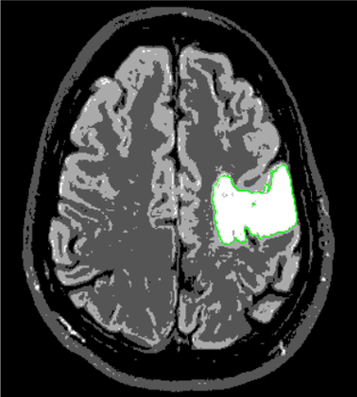

Fig. 8: Final Tumor classified image

## Chapter-4: DEVELOPMENT BASIS

## Feasibility Study

Any comprehension of the major specifications for the scheme is necessary for feasibility study. Feasibility Dimensions for Computers would be as shown in:

• **Technology**

Is the project technically possible?

Is it a component of the state of the art?

Will failure be limited to the need for an implementation meeting the level?

• **Finance**

Is it financially practicable?

Is it realistic for the software company and its customer or company to achieve production at a reasonable pace?

• **Time**

Can the time for the idea to be sold, beat the competition?

• **Resources**

Will the corporation have the capital necessary for success?

Two major variables used in the study of viability are:

a) Technical Feasibility

b) Cost Feasibility

c) Social Feasibility

## Technical Feasibility

The purpose of this analysis is to check the technological viability, that is to say, the system's technical requirements. Any built system does not have a strong need for the technological resources required. This will add to intense strains on the intellectual resources available. It would bring to the customer's already firm hopes. Since this system can only be applied with minor to no modifications, a bare minimum must be met.

In the following ways, practical evaluation of feasibility can be carried out.

1. NP-Complete
2. NP-Hard
3. **NP-Complete**

The P Class comprises of those issues which can be solved in polynomial time.

The NP class consists of such concerns which can be verified in polynomial time. If any further concern in NP can be converted (or reduced) into p in polynomial time, a question p in NP is NP-complete.

1. **NP-Hard**

There are problems where no such viable solutions have been identified. The complexities of these topics are usually more complex unlike P, NP, and NP-Complete. Relatively high multiplicative constants, exponent terms or polynomials of high order can be involved in this.

The purpose of the technical feasibility evaluation is to absorb about the institutions current technology assets and how well they match the needs of the preferred system. It is a test of the hardware and software to assess how well they meet the system's requirements.

## Cost Feasibility

This study evaluates the economic impact of the scheme on the business. It restricts the amount of money that can spend on the research and development of its strategy. It is necessary to justify the expenses. Thus, within the budget, the developed system was also developed and this was done because much of the technology used is readily accessible. It was only appropriate to buy the personalized items.

## Social Feasibility:

The purpose of the study is to determine the user's level of integration of the system. This covers the process of teaching the user how to effectively use the technology. The user should not be afraid of the system, but rather believe it as a need. The level of integration by users is purely determined by his acquaintance with the system. His self-esteem must be boosted so that he can offer productive evaluation, which is encouraged because he is the system's final user.

## Risk Management

## Risk Identification

* + Product Size Related

R1 Memory may be squandered as a result of additional lines of code or redundant algorithms.

* + Customer Related

R2 Since its consumer isn’t a professional individual and it poses a challenge in interpreting the customer's additional specifications.

R3 If the consumer offers unnecessary details; it can result in an undisclosed danger.

* + Process Risk

R4 A fuzzy or disruptive image may be analyzed throughout segmentation.

* + Development Environment Related

R5 When a client requests a change or makes an unnecessary alteration later in the implementation process, it is impossible to change the whole system configuration to accommodate the request.

R6 Inexperience and a lack of tool training can make it challenging to complete project modules.

## Strategies used to manage Risks

S1 By reducing redundant coding, we can prevent Chance R1.

S2 Meeting with the customer regularly reduces the risk to some extent.

S3 R3 properly develops the system to incorporate modifications at a later stage and retains all necessary paperwork to minimize the risk, as previously stated.

S4 Use an appropriate noise reduction algorithm prior to segmentation processing.

S5 As consumer demand changes, we will continue to increase the software's functionality.

S6 We will prevent R6 by providing adequate tool instruction.

## Testing

## Software Testing

## Introduction: -

The role of software testing is to ensure that programs are efficient and accurate. Software testing is an observational science investigation conducted to provide consumers with information regarding a product's quality in the environment in which it is intended to function. This can include but is not limited to running a program or application to detect errors.

## Testing Strategies:

## Unit Testing: -

In this case, each component is evaluated independently. The standards for defining unit test modules were selected to identify modules that have key functionality. A module may be either an individual or a method.

The unit testing functions that will be tested are as follows:

Choose the input image:

• Preprocessing can be used.

• Make use of segmentation.

• We are using Feature Extraction to extract features.

• Take out image with tumor identified on it.

## Integration Testing: -

During integration planning, suitable elements are integrated and examined as a group. Integration testing takes unit-tested pieces, such as data, and organises them into bigger aggregates, then applies integration test plan tests to those aggregates to create the integrated testing structure.

## Validation Testing: -

At the start or end of the production process, this approach is used to determine if the software satisfies the specified specifications.

## GUI Testing: -

The practice of reviewing a product's graphical user interface to check that it meets standards, such as maintaining direction connecting icons/buttons with source code, is known as GUI testing.

## Test Cases:

|  |  |
| --- | --- |
| Test Case Objective | Test Image Format |
| Explanation | Valid Image format must be processed for further execution |
| Steps | 1. Run Project  2. Choose image with compatible extension and proper format |
| Desired Outcome | Input image received and displayed |
| Outcome | As expected, |

|  |  |
| --- | --- |
| Test Case Objective | Checking Independent Panels |
| Explanation | Every panel on the window should work independently |
| Steps | * 1. Run Project   2. Select any Panel’s Radio button |
| Desired Outcome | The function should be performed respective to the Radio Button |
| Outcome | As expected, |

|  |  |
| --- | --- |
| Test Case Objective | Preprocessing and Features Extraction |
| Explanation | Image should be enhanced and property values must be extracted |
| Steps | Choose any scanned MR image |
| Desired Outcome | Should display the enhanced image and extracted values. |
| Outcome | As expected, |

|  |  |
| --- | --- |
| Test Case Objective | Tumor identification |
| Explanation | Tumor should be identified and located in results |
| Steps | Choose any scanned MR image |
| Desired Outcome | Should display the image with tumor identified and located onto it |
| Outcome | As expected, |

## Chapter-5: IMPLEMENTATION AND OUTPUTS

## Implementation

## Preprocessing:

Improve MR Image quality and make it in a form suited for further processing by human or machine vision system.

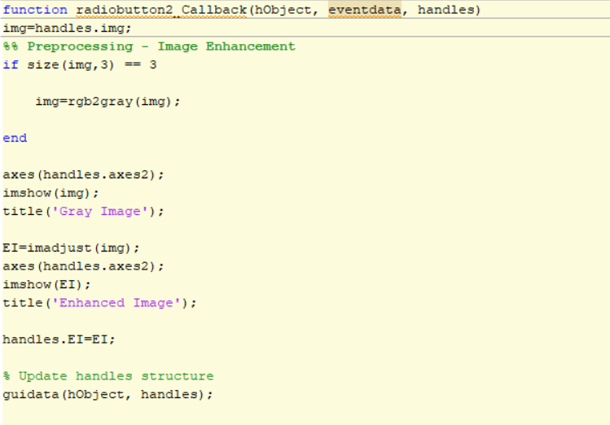

## Feature Extraction

Intensity, Contrast, Homogeneity and texture features of MRI images are extracted and used for classification.

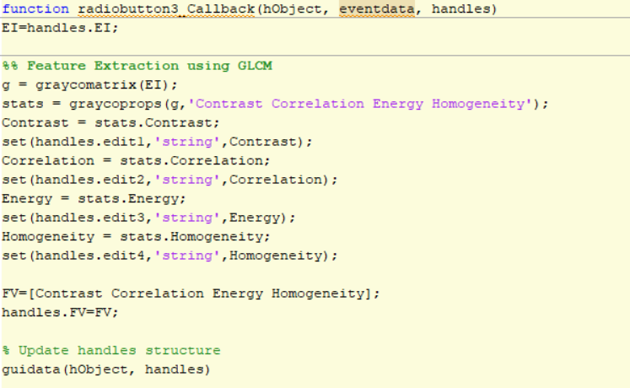

## Segmentation

We will use two separate segmentation techniques because we are applying Hybrid approach.

## Segmentation using K-means:

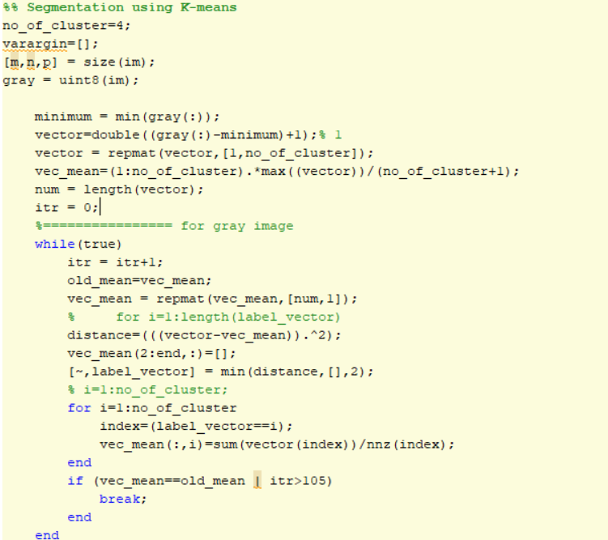

## Segmentation using FCM:

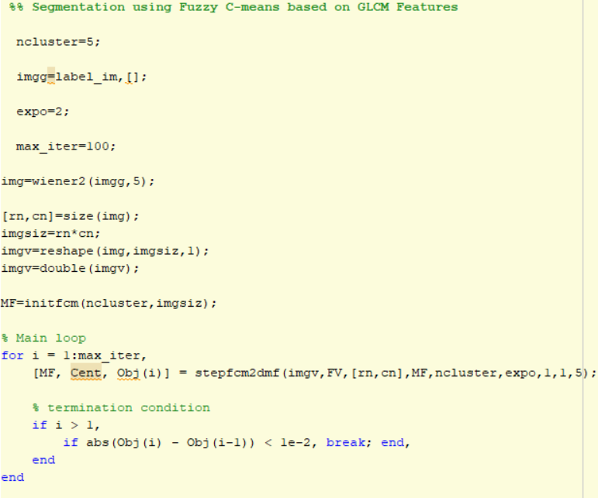

## Classification

Tumor classified Image after filtration.

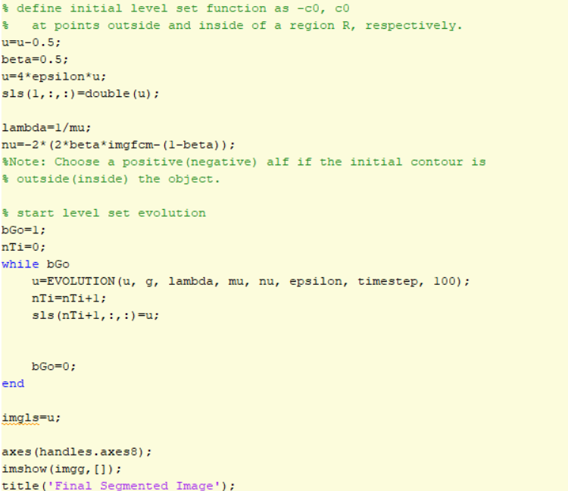

## Outputs

The outputs are labelled respective to the functions performed:

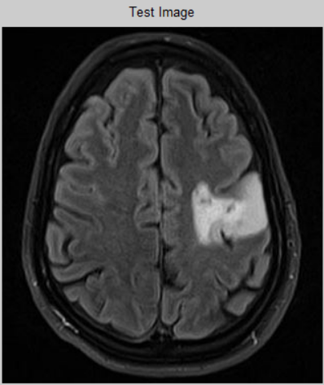

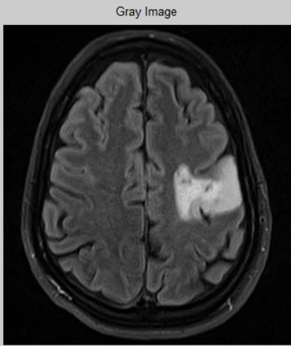

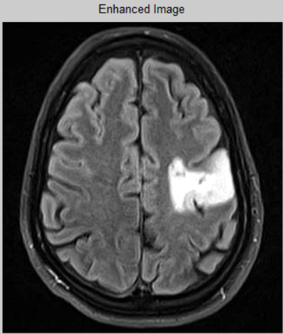

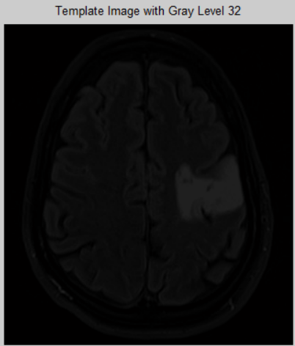

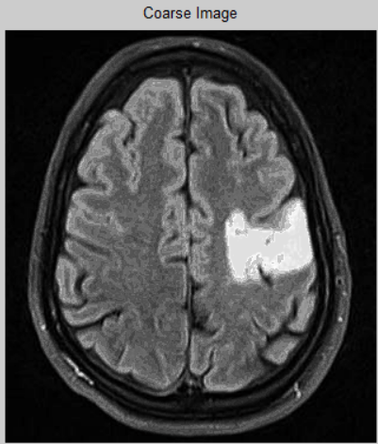

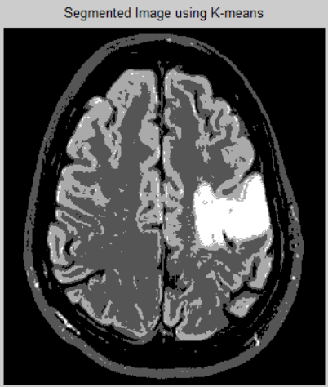

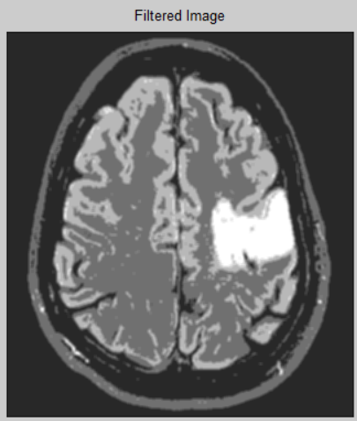

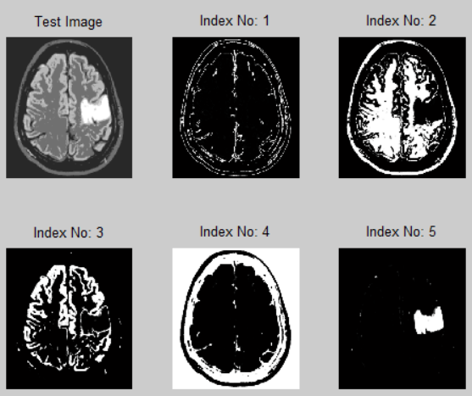

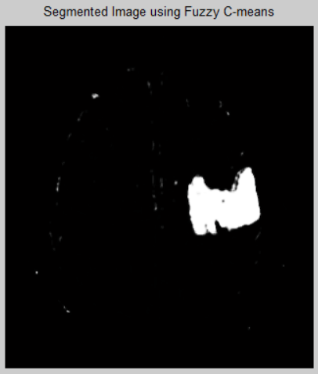

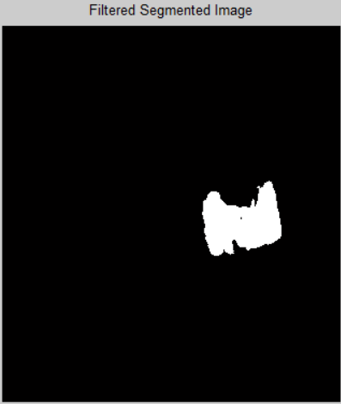

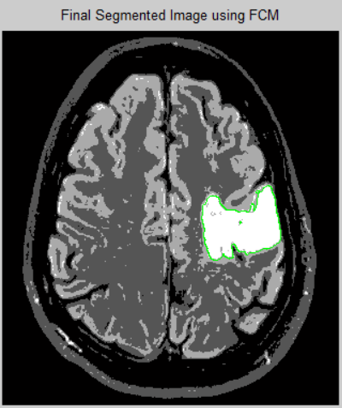

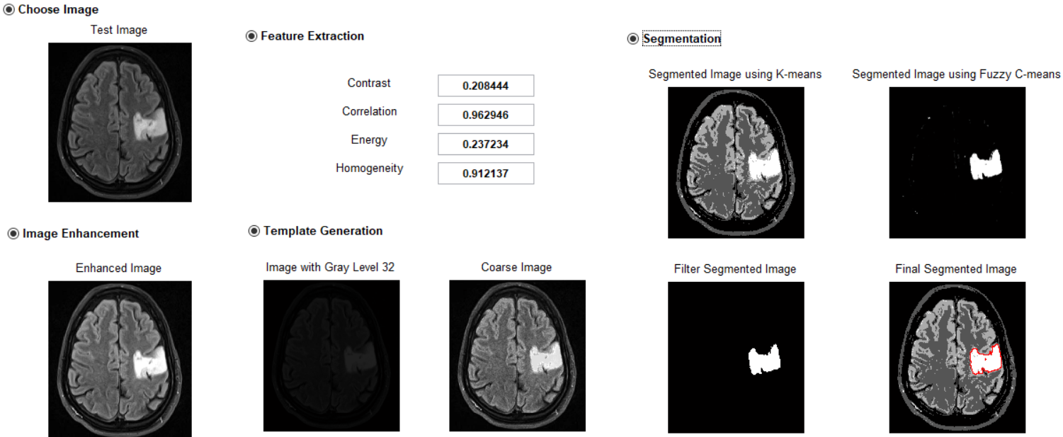

* + 1. 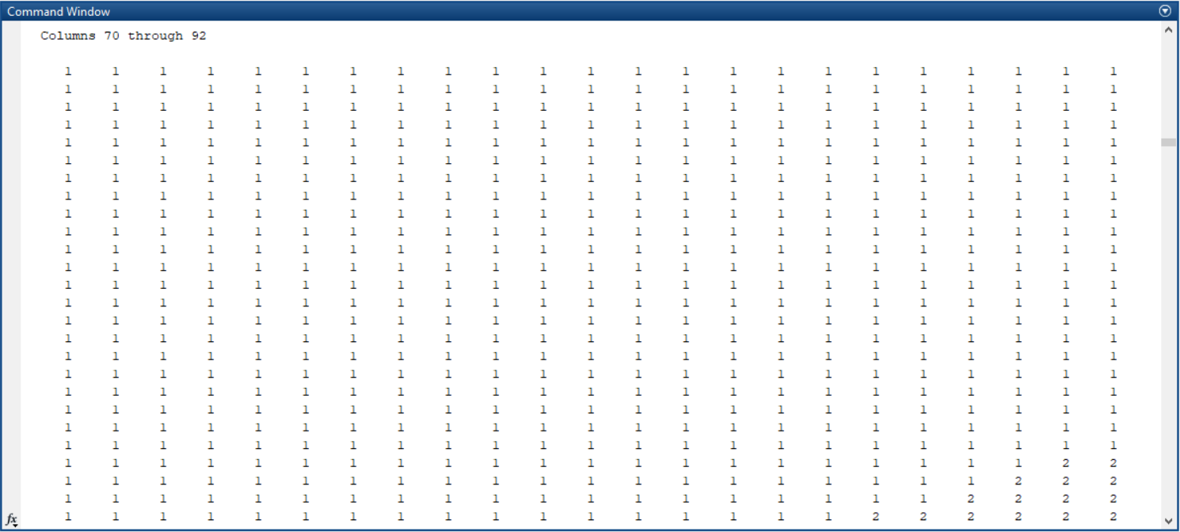

## Chapter-6: ADVANTAGES

* 1. **Advantages**
* The proposed approach is more computationally efficient,
  + Has a lower coefficient of variation,
  + Better results for overlapped test images,
  + And is resilient/applicable to a variety of tumor forms.
* When compared to previous graph-cut and grow-cut approaches, it achieves 80-90 percent overlap with minimum user intervention.
* Automated segmentation and tumor detection of brain MRI images.
  1. **Limitations**
* The various methods that can help the physicians without engaging with skin to detect the tumor but still it lacks with:
* Various human made disturbances like motion artifacts and ring artifacts, etc.
* Pixel irregularities within tainted tissue
* Noise produced naturally by electronic devices affecting the accuracy of tumor detection and there is still room for improvement which will be the main focus of this work.
* Intensity inhomogeneity or bias-field noise
* Partial volume effect

## Chapter-7: CONCLUSION

Many medical applications require image segmentation, and automated segmentation of brain tumors for cancer detection is a tedious exercise. The availability of public datasets such as the BRATS benchmark allows analysts to develop and test their modeled approaches using current approaches. This study has given a quick overview of the numerous methods, approaches, and models for segmenting the human brain that are routinely employed. As a result, medical image segmentation, specifically brain segmentation, is an unended challenge that requires to be more accurate and precise than any other medical image segmentation application.

## Chapter-8: FUTURE SCOPE

* With further improvement this technique can be applied on
  + Ovarian,
  + Breast,
  + Stomach and
  + Liver tumors.
* This technique can be developed to classify the tumors based on symmetry.

## Chapter-9: REFERENCES

1. Dachraoui C., Mouelhi A., Labidi S. (2022): “Brain MRI monitoring approach of lesion progress in multiple sclerosis using active contours.”
2. Stefano Cerri, Oula Puonti, Dominik S. Meier, Jens Wuerfel, Mark Muhlau, Hartwig R. Siebner, Koen Van Leemput (2021): “A Contrast-Adaptive Method for Simultaneous Whole-Brain and Lesion Segmentation in Multiple Sclerosis”, pp. 6.
3. M. Aarthilakshmi, S. Meenakshi, A. Poorna Pushkala, V. Rama@Ramalakshmi, N.B. Prakash (2020): “Brain Tumor Detection Using Machine Learning.”
4. Malav Bateriwala, Pierrick Bourgeat (2019): “Enforcing temporal consistency in Deep Learning segmentation of brain MR images”
5. Gudigar, A., Raghavendra, U., San, T. R., Ciaccio, E. J., & Acharya, U.R. (2019): “Application of multiresolution analysis for automated detection of brain abnormality using MR images: A comparative study.”
6. Bakas, S., Reyes, M., Jakab, A., Bauer, S., Rempfler, M., Crimi, A., … & Prastawa, M. (2018): “Identifying the best machine learning algorithms fr brain tumor segmentation, progression assessment, and overall survival prediction in the BRATS challenge.”
7. Nilesh Bhaskarrao Bahadure, Arun Kumar Ray, and Har Pal Thethi (2017): “Image Analysis for MRI Based Brain Tumor Detection and Feature Extraction Using Biologically Inspired BWT and SVM.”
8. Sanjeev Kumar, Chetna Dabas, Sunila Godara (2017): “Classification of Brain MRI Tumor Images: A Hybrid Approach.”
9. Ali, Direkolu C., Sah M. (2016): “Review of MRI-based brain tumor image segmentation using deep learning methods,” Procedia Computer Science, Vol: 102, pp: 317-324.
10. Anithadevi D., Karuppasamy Perumal (2016): “A Hybrid Approach based Segmentation Technique for Brain Tumor MRI Images.”
11. Despotovi, I., Goossens, B., & Philips, W. (2015): “MRI segmentation of the human brain: challenges, methods, and applications,” Computational and mathematical methods in medicine.
12. S. Damodharan and D. Raghavan (2015): “Combining tissue segmentation and neural network for brain tumor detection,” International Arab Journal of Information Technology, vol. 12, no. 1, pp. 42–52.
13. Mahmoud Al-Ayyoub, Ghaith Husari, Ahmad Alabed-alaziz (2015): “Machine Learning Approach for Brain Tumor Detection.”
14. SivaSankari.S, Sindhu.M, Sangeetha. R, ShenbagaRajan (2014): “Feature Extraction of Brain Tumor Using MRI,” Vol: 3.
15. Bauer S, Wiest R, Nolte L, Reyes M. (2013): “A survey of MRI-based medical image analysis for brain tumor studies.”
16. D.Selvaraj, R.Dhanasekaran (2013): “MRI Brain Image Segmentation Techniques – A review.”
17. E. A. Zanaty (2012): “Determination of gray matter (GM) and white matter (WM) volume in brain magnetic resonance images (MRI),” International Journal of Computer Applications, vol. 45, pp. 16–22.
18. D.L. Pham, J.L. Prince (2012): “Adaptive fuzzy segmentation of magnetic resonance images.”
19. Jonathan Morra, Zhuowen Tu, Arthur Toga, Paul Thompson (2012): “Machine Learning for Brain Image Segmentation.”
20. https://theprovince.com/diseases-and-conditions/cancer/brain-tumor-primary-adults